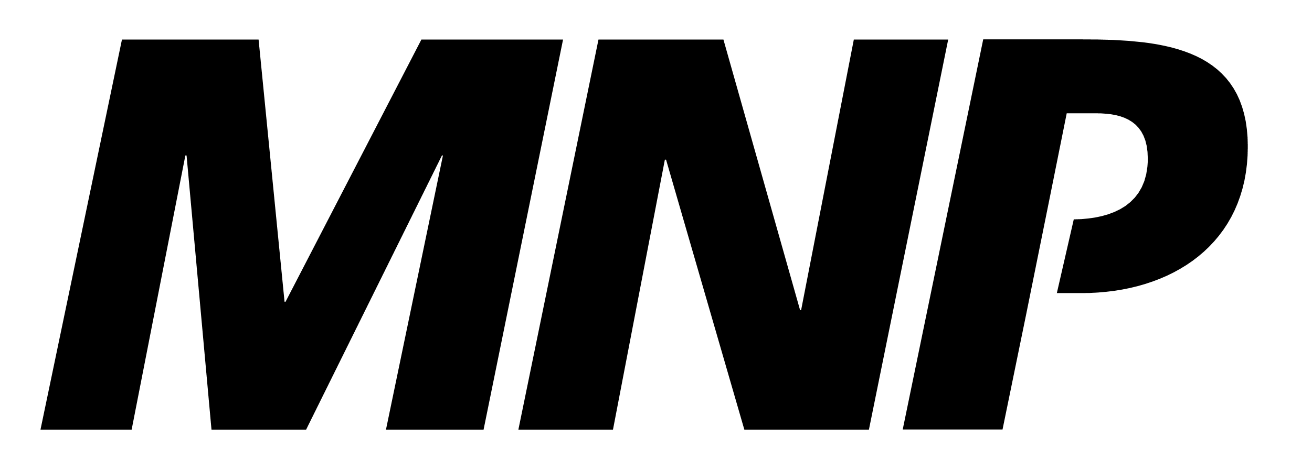

Join us for Community Meetings on January 24, 2023.

At this meeting, there will be a high level overview of the audited financial statements by the auditor of the March 31, 2022 financial statements of the Nation.

**Date:** Tuesday, January 24, 2023

**Time:** 5pm – 10pm

**Where:** Fox Lake Elementary School Gym

Food, beverages and door prizes will be provided!

Little Red is also in the process of creating a Comprehensive Community Plan (CCP). Attendees will be provided with a CCP handout and asked to share written feedback on the CCP at the meeting.

**Community Meeting Notice in**

**Fox Lake**